# Module 2 - Assignment 2

# Multiple Linear Regression and Special Issues

# Cooper, Sarah

library(tidyverse)

library(GGally)

library(MASS)

library(car)

library(gridExtra)

# Task 1

library(readr)  
hour <- read_csv("C:/Users/Sarah/Downloads/hour.csv")

## Parsed with column specification:  
## cols(  
## instant = col_double(),  
## dteday = col_date(format = ""),  
## season = col_double(),  
## yr = col_double(),  
## mnth = col_double(),  
## hr = col_double(),  
## holiday = col_double(),  
## weekday = col_double(),  
## workingday = col_double(),  
## weathersit = col_double(),  
## temp = col_double(),  
## atemp = col_double(),  
## hum = col_double(),  
## windspeed = col_double(),  
## casual = col_double(),  
## registered = col_double(),  
## count = col_double()  
## )

bike <- hour

bike = bike %>% mutate(season = as_factor(as.character(season))) %>%  
mutate(season = fct_recode(season,  
"Spring" = "1",  
"Summer" = "2",  
"Fall" = "3",  
"Winter" = "4"))

bike = bike %>% mutate(yr = as_factor(as.character(yr))) %>%  
mutate(yr = fct_recode(yr,  
"2012" = "1",  
"2011" = "0",))

bike = bike %>% mutate(mnth = as_factor(as.character(mnth))) %>%  
mutate(mnth = fct_recode(mnth,  
"Jan" = "1",  
"Feb" = "2",  
"Mar" = "3",  
"April" = "4",  
"May" = "5",  
"June" = "6",  
"July" = "7",  
"August" = "8",  
"Sept" = "9",  
"Oct" = "10",  
"Nov" = "11",  
"Dec" = "12"))

bike = bike %>% mutate(hr = as_factor(as.character(hr))) %>%  
mutate(hr = fct_recode(hr,  
"12:00am" = "0",  
"1:00am" = "1",  
"2:00am" = "2",  
"3:00am" = "3",  
"4:00am" = "4",  
"5:00am" = "5",  
"6:00am" = "6",  
"7:00am" = "7",  
"8:00am" = "8",  
"9:00am" = "9",  
"10:00am" = "10",  
"11:00am" = "11",  
"12:00pm" = "12",  
"1:00pm" = "13",  
"2:00pm" = "14",  
"3:00pm" = "15",  
"4:00pm" = "16",  
"5:00pm" = "17",  
"6:00pm" = "18",  
"7:00pm" = "19",  
"8:00pm" = "20",  
"9:00pm" = "21",  
"10:00pm" = "22",  
"11:00pm" = "23",))

bike = bike %>% mutate(holiday = as_factor(as.character(holiday))) %>%  
mutate(holiday = fct_recode(holiday,  
"NotHoliday" = "0",  
"Holiday" = "1",))

bike = bike %>% mutate(workingday = as_factor(as.character(workingday))) %>%  
mutate(workingday = fct_recode(workingday,  
"NotWorkingDay" = "0",  
"WorkingDay" = "1",))

bike = bike %>% mutate(weathersit = as_factor(as.character(weathersit))) %>%  
mutate(weathersit = fct_recode(weathersit,  
"NoPrecip" = "1",  
"Misty" = "2",  
"LightPrecip" = "3",  
"HeavyPrecip" = "4",))

bike = bike %>% mutate(weekday = as_factor(as.character(weekday))) %>%  
mutate(weekday = fct_recode(weekday,  
"Sunday" = "0",  
"Monday" = "1",  
"Tuesday" = "2",  
"Wednesday" = "3",  
"Thursday" = "4",  
"Friday" = "5",  
"Saturday" = "6",))

# Task 2

**At first glance, the Hr column appears to be best correlated with the Count column. The Atemp column also seems to correlate nicely with the Count column.**

# Task 3

ggpairs(bike, columns = c(3,5,7,8,9,10))

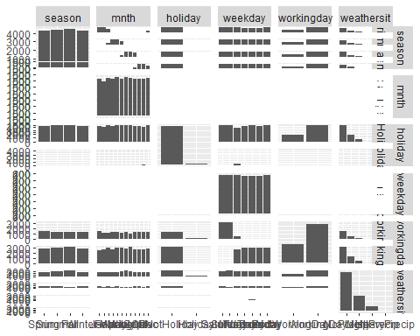

ggplot(bike, aes(x=count, y=season)) + geom_boxplot()

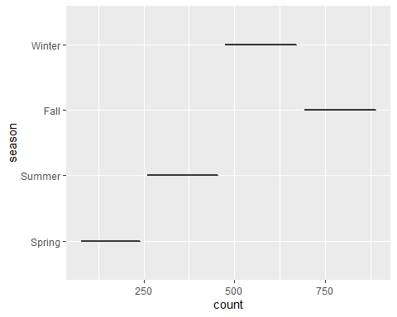

ggplot(bike, aes(x=count, y=mnth)) + geom_boxplot()

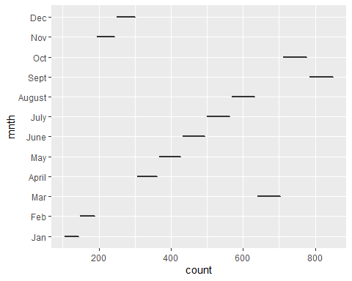

ggplot(bike, aes(x=count, y=holiday)) + geom_boxplot()

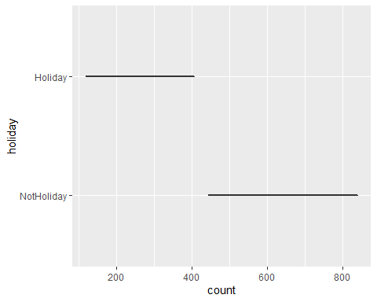

ggplot(bike, aes(x=count, y=weekday)) + geom_boxplot()

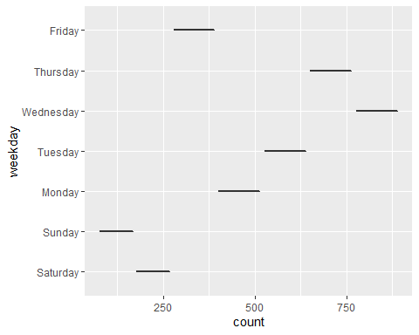

ggplot(bike, aes(x=count, y=workingday)) + geom_boxplot()

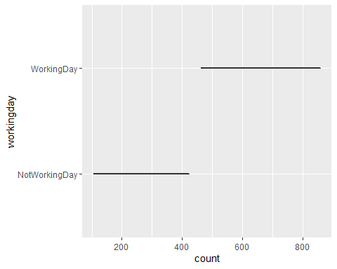

ggplot(bike, aes(x=count, y=weathersit)) + geom_boxplot()

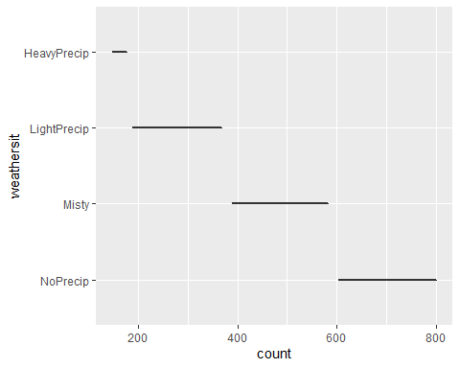

**It appears as though the highest number of rentals are occuring in the months of Sept and Oct (probably because the temperature is more pleasant than summer or winter), during the weekdays, not on a holiday, when there is no precipatation. These items would make sense to the working person as they may would need a means of travel to and from their office during a regular work week.**

# Task 4

bike2 = bike %>% dplyr::select("season","yr","mnth","hr","holiday","weekday","workingday","weathersit","temp","atemp","hum","windspeed","count")  
allmod = lm(count ~., bike2)  
summary(allmod)

##   
## Call:  
## lm(formula = count ~ ., data = bike2)  
##   
## Residuals:  
## Min 1Q Median 3Q Max   
## -393.87 -60.66 -7.96 51.31 439.18   
##   
## Coefficients: (1 not defined because of singularities)  
## Estimate Std. Error t value Pr(>|t|)   
## (Intercept) -67.542 6.612 -10.216 < 2e-16 ***  
## seasonSummer 38.178 4.856 7.862 4.00e-15 ***  
## seasonFall 32.055 5.749 5.575 2.51e-08 ***  
## seasonWinter 67.994 4.882 13.928 < 2e-16 ***  
## yr2012 85.431 1.563 54.658 < 2e-16 ***  
## mnthFeb 3.426 3.920 0.874 0.38219   
## mnthMar 14.299 4.407 3.244 0.00118 **   
## mnthApril 6.230 6.548 0.951 0.34144   
## mnthMay 20.657 7.007 2.948 0.00320 **   
## mnthJune 6.238 7.205 0.866 0.38662   
## mnthJuly -13.269 8.082 -1.642 0.10065   
## mnthAugust 7.897 7.879 1.002 0.31622   
## mnthSept 32.269 7.001 4.609 4.07e-06 ***  
## mnthOct 15.843 6.483 2.444 0.01455 *   
## mnthNov -9.840 6.238 -1.577 0.11474   
## mnthDec -6.256 4.954 -1.263 0.20672   
## hr1:00am -17.294 5.345 -3.236 0.00122 **   
## hr2:00am -26.369 5.364 -4.916 8.91e-07 ***  
## hr3:00am -37.112 5.403 -6.869 6.67e-12 ***  
## hr4:00am -40.263 5.408 -7.445 1.01e-13 ***  
## hr5:00am -23.501 5.373 -4.374 1.23e-05 ***  
## hr6:00am 35.393 5.359 6.605 4.10e-11 ***  
## hr7:00am 170.418 5.348 31.864 < 2e-16 ***  
## hr8:00am 310.801 5.342 58.183 < 2e-16 ***  
## hr9:00am 163.101 5.347 30.501 < 2e-16 ***  
## hr10:00am 108.444 5.370 20.196 < 2e-16 ***  
## hr11:00am 133.843 5.409 24.742 < 2e-16 ***  
## hr12:00pm 173.142 5.456 31.735 < 2e-16 ***  
## hr1:00pm 168.102 5.494 30.600 < 2e-16 ***  
## hr2:00pm 152.249 5.525 27.558 < 2e-16 ***  
## hr3:00pm 161.707 5.535 29.213 < 2e-16 ***  
## hr4:00pm 223.834 5.524 40.522 < 2e-16 ***  
## hr5:00pm 377.535 5.491 68.750 < 2e-16 ***  
## hr6:00pm 345.587 5.455 63.350 < 2e-16 ***  
## hr7:00pm 236.919 5.404 43.841 < 2e-16 ***  
## hr8:00pm 157.293 5.375 29.266 < 2e-16 ***  
## hr9:00pm 107.840 5.353 20.147 < 2e-16 ***  
## hr10:00pm 70.907 5.343 13.272 < 2e-16 ***  
## hr11:00pm 32.112 5.338 6.015 1.83e-09 ***  
## holidayHoliday -26.228 4.881 -5.374 7.81e-08 ***  
## weekdaySunday -16.089 2.878 -5.591 2.30e-08 ***  
## weekdayMonday -6.814 2.970 -2.294 0.02180 *   
## weekdayTuesday -5.240 2.899 -1.807 0.07071 .   
## weekdayWednesday -2.464 2.894 -0.851 0.39469   
## weekdayThursday -2.940 2.892 -1.016 0.30947   
## weekdayFriday 1.356 2.885 0.470 0.63823   
## workingdayWorkingDay NA NA NA NA   
## weathersitMisty -10.409 1.920 -5.421 6.00e-08 ***  
## weathersitLightPrecip -65.189 3.236 -20.145 < 2e-16 ***  
## weathersitHeavyPrecip -62.580 58.893 -1.063 0.28797   
## temp 116.384 29.513 3.943 8.06e-05 ***  
## atemp 127.975 30.624 4.179 2.94e-05 ***  
## hum -82.802 5.554 -14.909 < 2e-16 ***  
## windspeed -29.167 7.052 -4.136 3.55e-05 ***  
## ---  
## Signif. codes: 0 '***' 0.001 '**' 0.01 '*' 0.05 '.' 0.1 ' ' 1  
##   
## Residual standard error: 101.7 on 17326 degrees of freedom  
## Multiple R-squared: 0.6864, Adjusted R-squared: 0.6854   
## F-statistic: 729.1 on 52 and 17326 DF, p-value: < 2.2e-16

emptymod = lm(count ~1, bike2)  
summary(emptymod)

##   
## Call:  
## lm(formula = count ~ 1, data = bike2)  
##   
## Residuals:  
## Min 1Q Median 3Q Max   
## -188.46 -149.46 -47.46 91.54 787.54   
##   
## Coefficients:  
## Estimate Std. Error t value Pr(>|t|)   
## (Intercept) 189.463 1.376 137.7 <2e-16 ***  
## ---  
## Signif. codes: 0 '***' 0.001 '**' 0.01 '*' 0.05 '.' 0.1 ' ' 1  
##   
## Residual standard error: 181.4 on 17378 degrees of freedom

forwardmod = stepAIC(emptymod, direction = "forward", scope=list(upper=allmod, lower=emptymod),trace = TRUE)

## Start: AIC=180764.7  
## count ~ 1  
##   
## Df Sum of Sq RSS AIC  
## + hr 23 286734681 285026910 168713  
## + temp 1 93677759 478083832 177657  
## + atemp 1 91907421 479854170 177721  
## + hum 1 59618351 512143240 178853  
## + mnth 11 42909976 528851615 179431  
## + season 3 37729358 534032233 179584  
## + yr 1 35876722 535884870 179641  
## + weathersit 3 12285030 559476561 180393  
## + windspeed 1 4970060 566791531 180615  
## + holiday 1 546889 571214702 180750  
## + workingday 1 524387 571237204 180751  
## + weekday 6 687929 571073662 180756  
## <none> 571761591 180765  
##   
## Step: AIC=168712.5  
## count ~ hr  
##   
## Df Sum of Sq RSS AIC  
## + atemp 1 50518941 234507969 165324  
## + temp 1 50101685 234925225 165355  
## + mnth 11 44822160 240204750 165761  
## + season 3 39619754 245407156 166117  
## + yr 1 36875130 248151780 166307  
## + weathersit 3 13766672 271260238 167858  
## + hum 1 4924310 280102600 168412  
## + windspeed 1 1476211 283550699 168624  
## + holiday 1 561784 284465126 168680  
## + weekday 6 719530 284307380 168681  
## + workingday 1 485366 284541544 168685  
## <none> 285026910 168713  
##   
## Step: AIC=165324  
## count ~ hr + atemp  
##   
## Df Sum of Sq RSS AIC  
## + yr 1 33463769 201044200 162650  
## + weathersit 3 9227265 225280704 164632  
## + hum 1 7008684 227499285 164799  
## + season 3 6580442 227927527 164835  
## + mnth 11 5854560 228653409 164907  
## + weekday 6 607638 233900331 165291  
## + holiday 1 274006 234233963 165306  
## + temp 1 152153 234355816 165315  
## + windspeed 1 120557 234387412 165317  
## + workingday 1 90170 234417799 165319  
## <none> 234507969 165324  
##   
## Step: AIC=162650.2  
## count ~ hr + atemp + yr  
##   
## Df Sum of Sq RSS AIC  
## + weathersit 3 8408358 192635842 161914  
## + season 3 7190305 193853896 162023  
## + mnth 11 6486062 194558138 162102  
## + hum 1 4341837 196702363 162273  
## + weekday 6 641648 200402552 162607  
## + holiday 1 324763 200719438 162624  
## + windspeed 1 109311 200934889 162643  
## + workingday 1 106404 200937797 162643  
## + temp 1 91735 200952465 162644  
## <none> 201044200 162650  
##   
## Step: AIC=161913.7  
## count ~ hr + atemp + yr + weathersit  
##   
## Df Sum of Sq RSS AIC  
## + season 3 7771024 184864818 161204  
## + mnth 11 7464989 185170852 161249  
## + hum 1 805099 191830743 161843  
## + weekday 6 686172 191949670 161864  
## + holiday 1 413536 192222305 161878  
## + workingday 1 212428 192423414 161897  
## + temp 1 134482 192501360 161904  
## + windspeed 1 44407 192591435 161912  
## <none> 192635842 161914  
##   
## Step: AIC=161204.1  
## count ~ hr + atemp + yr + weathersit + season  
##   
## Df Sum of Sq RSS AIC  
## + mnth 11 2051323 182813495 161032  
## + hum 1 1810161 183054657 161035  
## + weekday 6 704303 184160515 161150  
## + holiday 1 392702 184472116 161169  
## + temp 1 352584 184512234 161173  
## + workingday 1 214973 184649845 161186  
## <none> 184864818 161204  
## + windspeed 1 158 184864660 161206  
##   
## Step: AIC=161032.2  
## count ~ hr + atemp + yr + weathersit + season + mnth  
##   
## Df Sum of Sq RSS AIC  
## + hum 1 2356411 180457084 160809  
## + weekday 6 692672 182120823 160978  
## + holiday 1 312321 182501174 161004  
## + temp 1 233052 182580443 161012  
## + workingday 1 203953 182609542 161015  
## <none> 182813495 161032  
## + windspeed 1 68 182813428 161034  
##   
## Step: AIC=160808.7  
## count ~ hr + atemp + yr + weathersit + season + mnth + hum  
##   
## Df Sum of Sq RSS AIC  
## + weekday 6 581105 179875980 160765  
## + holiday 1 322997 180134087 160780  
## + workingday 1 194139 180262945 160792  
## + windspeed 1 114287 180342797 160800  
## + temp 1 100025 180357059 160801  
## <none> 180457084 160809  
##   
## Step: AIC=160764.7  
## count ~ hr + atemp + yr + weathersit + season + mnth + hum +   
## weekday  
##   
## Df Sum of Sq RSS AIC  
## + holiday 1 274717 179601263 160740  
## + workingday 1 274717 179601263 160740  
## + windspeed 1 112085 179763895 160756  
## + temp 1 77171 179798809 160759  
## <none> 179875980 160765  
##   
## Step: AIC=160740.1  
## count ~ hr + atemp + yr + weathersit + season + mnth + hum +   
## weekday + holiday  
##   
## Df Sum of Sq RSS AIC  
## + windspeed 1 111562 179489701 160731  
## + temp 1 95460 179505803 160733  
## <none> 179601263 160740  
##   
## Step: AIC=160731.3  
## count ~ hr + atemp + yr + weathersit + season + mnth + hum +   
## weekday + holiday + windspeed  
##   
## Df Sum of Sq RSS AIC  
## + temp 1 160954 179328746 160718  
## <none> 179489701 160731  
##   
## Step: AIC=160717.7  
## count ~ hr + atemp + yr + weathersit + season + mnth + hum +   
## weekday + holiday + windspeed + temp  
##   
## Df Sum of Sq RSS AIC  
## <none> 179328746 160718

summary(forwardmod)

##   
## Call:  
## lm(formula = count ~ hr + atemp + yr + weathersit + season +   
## mnth + hum + weekday + holiday + windspeed + temp, data = bike2)  
##   
## Residuals:  
## Min 1Q Median 3Q Max   
## -393.87 -60.66 -7.96 51.31 439.18   
##   
## Coefficients:  
## Estimate Std. Error t value Pr(>|t|)   
## (Intercept) -67.542 6.612 -10.216 < 2e-16 ***  
## hr1:00am -17.294 5.345 -3.236 0.00122 **   
## hr2:00am -26.369 5.364 -4.916 8.91e-07 ***  
## hr3:00am -37.112 5.403 -6.869 6.67e-12 ***  
## hr4:00am -40.263 5.408 -7.445 1.01e-13 ***  
## hr5:00am -23.501 5.373 -4.374 1.23e-05 ***  
## hr6:00am 35.393 5.359 6.605 4.10e-11 ***  
## hr7:00am 170.418 5.348 31.864 < 2e-16 ***  
## hr8:00am 310.801 5.342 58.183 < 2e-16 ***  
## hr9:00am 163.101 5.347 30.501 < 2e-16 ***  
## hr10:00am 108.444 5.370 20.196 < 2e-16 ***  
## hr11:00am 133.843 5.409 24.742 < 2e-16 ***  
## hr12:00pm 173.142 5.456 31.735 < 2e-16 ***  
## hr1:00pm 168.102 5.494 30.600 < 2e-16 ***  
## hr2:00pm 152.249 5.525 27.558 < 2e-16 ***  
## hr3:00pm 161.707 5.535 29.213 < 2e-16 ***  
## hr4:00pm 223.834 5.524 40.522 < 2e-16 ***  
## hr5:00pm 377.535 5.491 68.750 < 2e-16 ***  
## hr6:00pm 345.587 5.455 63.350 < 2e-16 ***  
## hr7:00pm 236.919 5.404 43.841 < 2e-16 ***  
## hr8:00pm 157.293 5.375 29.266 < 2e-16 ***  
## hr9:00pm 107.840 5.353 20.147 < 2e-16 ***  
## hr10:00pm 70.907 5.343 13.272 < 2e-16 ***  
## hr11:00pm 32.112 5.338 6.015 1.83e-09 ***  
## atemp 127.975 30.624 4.179 2.94e-05 ***  
## yr2012 85.431 1.563 54.658 < 2e-16 ***  
## weathersitMisty -10.409 1.920 -5.421 6.00e-08 ***  
## weathersitLightPrecip -65.189 3.236 -20.145 < 2e-16 ***  
## weathersitHeavyPrecip -62.580 58.893 -1.063 0.28797   
## seasonSummer 38.178 4.856 7.862 4.00e-15 ***  
## seasonFall 32.055 5.749 5.575 2.51e-08 ***  
## seasonWinter 67.994 4.882 13.928 < 2e-16 ***  
## mnthFeb 3.426 3.920 0.874 0.38219   
## mnthMar 14.299 4.407 3.244 0.00118 **   
## mnthApril 6.230 6.548 0.951 0.34144   
## mnthMay 20.657 7.007 2.948 0.00320 **   
## mnthJune 6.238 7.205 0.866 0.38662   
## mnthJuly -13.269 8.082 -1.642 0.10065   
## mnthAugust 7.897 7.879 1.002 0.31622   
## mnthSept 32.269 7.001 4.609 4.07e-06 ***  
## mnthOct 15.843 6.483 2.444 0.01455 *   
## mnthNov -9.840 6.238 -1.577 0.11474   
## mnthDec -6.256 4.954 -1.263 0.20672   
## hum -82.802 5.554 -14.909 < 2e-16 ***  
## weekdaySunday -16.089 2.878 -5.591 2.30e-08 ***  
## weekdayMonday -6.814 2.970 -2.294 0.02180 *   
## weekdayTuesday -5.240 2.899 -1.807 0.07071 .   
## weekdayWednesday -2.464 2.894 -0.851 0.39469   
## weekdayThursday -2.940 2.892 -1.016 0.30947   
## weekdayFriday 1.356 2.885 0.470 0.63823   
## holidayHoliday -26.228 4.881 -5.374 7.81e-08 ***  
## windspeed -29.167 7.052 -4.136 3.55e-05 ***  
## temp 116.384 29.513 3.943 8.06e-05 ***  
## ---  
## Signif. codes: 0 '***' 0.001 '**' 0.01 '*' 0.05 '.' 0.1 ' ' 1  
##   
## Residual standard error: 101.7 on 17326 degrees of freedom  
## Multiple R-squared: 0.6864, Adjusted R-squared: 0.6854   
## F-statistic: 729.1 on 52 and 17326 DF, p-value: < 2.2e-16

**The forward model decided to include variables such as season, hour, month, weekday, weather, temperature, atemp, humidity, and windspeed. I believe the model includes more factors that perhaps I would have but, nonetheless they are insightful variables to consider. It’s my opinion that we may be seeing evidence of multicollinearity in the holiday field.**

# Task 5

backmod = stepAIC(allmod, direction = "backward", trace = TRUE)

## Start: AIC=160717.7  
## count ~ season + yr + mnth + hr + holiday + weekday + workingday +   
## weathersit + temp + atemp + hum + windspeed  
##   
##   
## Step: AIC=160717.7  
## count ~ season + yr + mnth + hr + holiday + weekday + weathersit +   
## temp + atemp + hum + windspeed  
##   
## Df Sum of Sq RSS AIC  
## <none> 179328746 160718  
## - temp 1 160954 179489701 160731  
## - windspeed 1 177057 179505803 160733  
## - atemp 1 180751 179509498 160733  
## - holiday 1 298893 179627639 160745  
## - weekday 6 498795 179827541 160754  
## - mnth 11 2426171 181754917 160929  
## - hum 1 2300667 181629413 160937  
## - season 3 2398467 181727213 160943  
## - weathersit 3 4208731 183537478 161115  
## - yr 1 30920851 210249597 163480  
## - hr 23 196741474 376070220 173542

summary(backmod)

##   
## Call:  
## lm(formula = count ~ season + yr + mnth + hr + holiday + weekday +   
## weathersit + temp + atemp + hum + windspeed, data = bike2)  
##   
## Residuals:  
## Min 1Q Median 3Q Max   
## -393.87 -60.66 -7.96 51.31 439.18   
##   
## Coefficients:  
## Estimate Std. Error t value Pr(>|t|)   
## (Intercept) -67.542 6.612 -10.216 < 2e-16 ***  
## seasonSummer 38.178 4.856 7.862 4.00e-15 ***  
## seasonFall 32.055 5.749 5.575 2.51e-08 ***  
## seasonWinter 67.994 4.882 13.928 < 2e-16 ***  
## yr2012 85.431 1.563 54.658 < 2e-16 ***  
## mnthFeb 3.426 3.920 0.874 0.38219   
## mnthMar 14.299 4.407 3.244 0.00118 **   
## mnthApril 6.230 6.548 0.951 0.34144   
## mnthMay 20.657 7.007 2.948 0.00320 **   
## mnthJune 6.238 7.205 0.866 0.38662   
## mnthJuly -13.269 8.082 -1.642 0.10065   
## mnthAugust 7.897 7.879 1.002 0.31622   
## mnthSept 32.269 7.001 4.609 4.07e-06 ***  
## mnthOct 15.843 6.483 2.444 0.01455 *   
## mnthNov -9.840 6.238 -1.577 0.11474   
## mnthDec -6.256 4.954 -1.263 0.20672   
## hr1:00am -17.294 5.345 -3.236 0.00122 **   
## hr2:00am -26.369 5.364 -4.916 8.91e-07 ***  
## hr3:00am -37.112 5.403 -6.869 6.67e-12 ***  
## hr4:00am -40.263 5.408 -7.445 1.01e-13 ***  
## hr5:00am -23.501 5.373 -4.374 1.23e-05 ***  
## hr6:00am 35.393 5.359 6.605 4.10e-11 ***  
## hr7:00am 170.418 5.348 31.864 < 2e-16 ***  
## hr8:00am 310.801 5.342 58.183 < 2e-16 ***  
## hr9:00am 163.101 5.347 30.501 < 2e-16 ***  
## hr10:00am 108.444 5.370 20.196 < 2e-16 ***  
## hr11:00am 133.843 5.409 24.742 < 2e-16 ***  
## hr12:00pm 173.142 5.456 31.735 < 2e-16 ***  
## hr1:00pm 168.102 5.494 30.600 < 2e-16 ***  
## hr2:00pm 152.249 5.525 27.558 < 2e-16 ***  
## hr3:00pm 161.707 5.535 29.213 < 2e-16 ***  
## hr4:00pm 223.834 5.524 40.522 < 2e-16 ***  
## hr5:00pm 377.535 5.491 68.750 < 2e-16 ***  
## hr6:00pm 345.587 5.455 63.350 < 2e-16 ***  
## hr7:00pm 236.919 5.404 43.841 < 2e-16 ***  
## hr8:00pm 157.293 5.375 29.266 < 2e-16 ***  
## hr9:00pm 107.840 5.353 20.147 < 2e-16 ***  
## hr10:00pm 70.907 5.343 13.272 < 2e-16 ***  
## hr11:00pm 32.112 5.338 6.015 1.83e-09 ***  
## holidayHoliday -26.228 4.881 -5.374 7.81e-08 ***  
## weekdaySunday -16.089 2.878 -5.591 2.30e-08 ***  
## weekdayMonday -6.814 2.970 -2.294 0.02180 *   
## weekdayTuesday -5.240 2.899 -1.807 0.07071 .   
## weekdayWednesday -2.464 2.894 -0.851 0.39469   
## weekdayThursday -2.940 2.892 -1.016 0.30947   
## weekdayFriday 1.356 2.885 0.470 0.63823   
## weathersitMisty -10.409 1.920 -5.421 6.00e-08 ***  
## weathersitLightPrecip -65.189 3.236 -20.145 < 2e-16 ***  
## weathersitHeavyPrecip -62.580 58.893 -1.063 0.28797   
## temp 116.384 29.513 3.943 8.06e-05 ***  
## atemp 127.975 30.624 4.179 2.94e-05 ***  
## hum -82.802 5.554 -14.909 < 2e-16 ***  
## windspeed -29.167 7.052 -4.136 3.55e-05 ***  
## ---  
## Signif. codes: 0 '***' 0.001 '**' 0.01 '*' 0.05 '.' 0.1 ' ' 1  
##   
## Residual standard error: 101.7 on 17326 degrees of freedom  
## Multiple R-squared: 0.6864, Adjusted R-squared: 0.6854   
## F-statistic: 729.1 on 52 and 17326 DF, p-value: < 2.2e-16

**The backward and forward models do not differ.**

# Task 6

**Workingday may be perfectly correlated with the variables weekdayWednesday, weekdayThursday, or weekdayFriday as the model determined these variables to be not at all significant.**

# Task 7

**I personally prefer the usability of our first model present in Task 4 over the preceeding models. The first model is more user friendly (easily read) and trust worthy. The backward and foreward models are too similar that one cannot determine which contains more validity between the two. Since we’ve now learned that the first model has a tendency to disregard or mislabel the importance of a variable based on how closely it matches another, I would be cautious in the interpretation of the significance asterisks.**